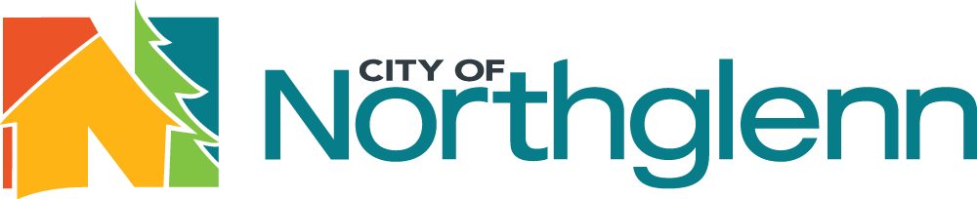
2021

Outside Agency Funding Grant Application

Organization Information
Organization Name:
Name of Executive Director:
Application Contact & Title:
Organization Address:
City: |  | State: |  |  | Zip:
Phone: |  | Email:
Organization Website:
Social Media Accounts/Names:
Year Founded: | Number of Employees:
Not-For-Profit Status (must be non-profit to receive outside agency funding)
Non-Profit Entity Yes No |  |  |  | Registered in Colorado Yes No
Mission/Purpose of the Organization (attach additional documentation if needed):

Grant Request Information
Type of Grant Requested (select one):
General Operating Support
Program or Project Support; Name of Program or Project:
Other:
Program/Project Budget: |  |  | Requested Grant Amount:
Describe what the grant will be used for:

How would the grant funding be used if the request is partially funded?

Describe the programs and services provided by your organization.

Is there an identified community need for your organization’s programs and services in Northglenn?

Describe how your programs and services directly benefit Northglenn residents, and identify the estimated number of Northglenn residents your organization will serve in 2021:

How does your organization determine the effectiveness of the programs?

Based on funding in 2020, please list your organization’s top five funding sources (corporate, government, and individual contributions) and the amounts received from these sources:
1.
2.
3.
4.
5.
Has your organization requested other funding from the City of Northglenn in 2021? Yes No
If so, please list the other requests:
Please list the names of other organizations in the community that provide the same or similar services as your organization.

Submit a completed application and attachments via email to jsmall@northglenn.org
or mail to: City of Northglenn, Attn: City Clerk’s Office, 11701 Community Center Drive, Northglenn, CO 80233.
Completed applications must be received no later than 4:30 p.m. on November 29, 2021.

